**SHARJEEL MEMON (BCS-2E)**

**24K-0555**

**FAST UNIVERSITY**

**LECTURER: RAMSHA IQBAL**

****DIGITAL LOGIC DESIGN LAB-2****

**QUESTION NO.1**

**Q1: Implement the following logic circuit on Logism, and write Boolean Expression and draw Truth table.**

|  |  |  |  |  |  |  |  |
| --- | --- | --- | --- | --- | --- | --- | --- |
| A | B | C | AB | B+C | BC | BC(B+C) | AB +BC(B+C) |
| 0 | 0 | 0 | 0 | 0 | 0 | 0 | 0 |
| 0 | 0 | 1 | 0 | 1 | 0 | 0 | 0 |
| 0 | 1 | 0 | 0 | 1 | 0 | 0 | 0 |
| 0 | 1 | 1 | 0 | 1 | 1 | 1 | 1 |
| 1 | 0 | 0 | 0 | 0 | 0 | 0 | 0 |
| 1 | 0 | 1 | 0 | 1 | 0 | 0 | 0 |
| 1 | 1 | 0 | 1 | 1 | 0 | 0 | 1 |
| 1 | 1 | 1 | 1 | 1 | 1 | 1 | 1 |

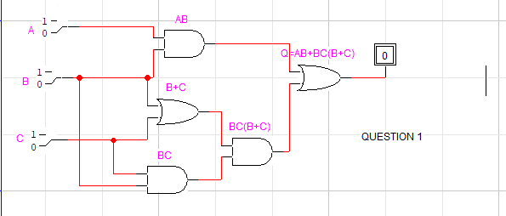

**QUESTION NO.2**

**Q2:Draw the logic circuit represented by each of the following expression:**

**1. A+B+C+D**

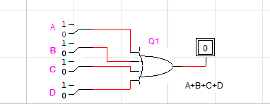

1. **ABCD**

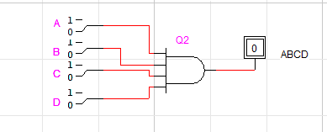

**3. A+BC**

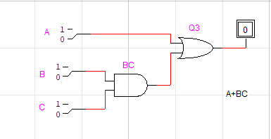

**4. ABC+D**

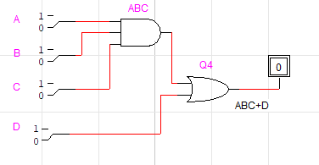

1. **(A’ +BC)’**

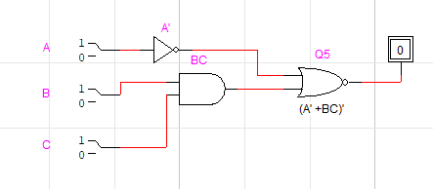

**QUESTION NO.3**

**Q3:Implement the following logic circuit on logic trainer, and write truth table in the space provided below:**

|  |  |  |  |  |  |  |  |
| --- | --- | --- | --- | --- | --- | --- | --- |
| A | B | C | D | A.B | D' | A.B + C | (A.B +C).D' |
| 0 | 0 | 0 | 0 | 0 | 1 | 0 | 0 |
| 0 | 0 | 0 | 1 | 0 | 0 | 0 | 0 |
| 0 | 0 | 1 | 0 | 0 | 1 | 1 | 1 |
| 0 | 0 | 1 | 1 | 0 | 0 | 1 | 0 |
| 0 | 1 | 0 | 0 | 0 | 1 | 0 | 0 |
| 0 | 1 | 0 | 1 | 0 | 0 | 0 | 0 |
| 0 | 1 | 1 | 0 | 0 | 1 | 1 | 1 |
| 0 | 1 | 1 | 1 | 0 | 0 | 1 | 0 |
| 1 | 0 | 0 | 0 | 0 | 1 | 0 | 0 |
| 1 | 0 | 0 | 1 | 0 | 0 | 0 | 0 |
| 1 | 0 | 1 | 0 | 0 | 1 | 1 | 1 |
| 1 | 0 | 1 | 1 | 0 | 0 | 1 | 0 |
| 1 | 1 | 0 | 0 | 1 | 1 | 1 | 1 |
| 1 | 1 | 0 | 1 | 1 | 0 | 1 | 0 |
| 1 | 1 | 1 | 0 | 1 | 1 | 1 | 1 |
| 1 | 1 | 1 | 1 | 1 | 0 | 1 | 0 |

